Test Station Development Using the UCF Framework v030123
Richard Todd
Test Engineering Services
Requires libTeSequencer.(so | dll) v012623 or later.
Requires UniConsole(.exe) v012623 or later.
Requires StdIOChannelSystem(.so | dll) v012623 or later.

Table of Contents
1. Purpose 3
2. Terminology 3
3. Related Documents 3
4. Pre-Conditions 4
4.1. Initial Test Specification 4
4.2. Test Station Hardware Design and Fabrication 4
4.3. UCF Installation 4
5. UCF Overview 4
5.1. Management Console 4
5.2. Test Executive 4
5.3. Plugin Based Architecture 4
5.4. Standardized Deployment Structure 4
6. Test Sequences and Functions 5
6.1. Test Session Execution using the Executive 5
6.2. Test Session Execution using the Management Console 6
6.3. Test Function Execution using the Management Console 7
6.4. Viewing Utility Commands 8
6.5. Executing Utility Commands. 8
7. The Development Process Outline 9
8. Test Profile Creation 9
8.1. Creating a Test Group & Profile Structure 9
a) Directory and File Descriptions 10
9. Software Development Project Creation 11
9.1. Project Creation 11
9.2. Project Configuration 11
9.3. Project Verification 11
10. UCF API Functions 12
10.1. Registering a Utility Function 12
a) Example Code 12
10.2. Registering aTest Step 12
a) Example Code 12
10.3. Creating a UCF API Function 13
a) Example Code 13
b) Additional iUcfTestExec methods 14
11. IO Channels 15
11.1. Defining IO Channels 15
a) Database Locations 15
b) Defining Communication Parameters 15
c) Viewing IO Channel Definitions 15
11.2. Creating IO Channels 16
a) Location 16
b) Creating Instrument IO Channels 16
c) Creating UUT IO Channels 16
d) Viewing Instrument IO Channels 16
e) Example Code 17
12. External Device Control 18
12.1. Initialization 18
a) Code Location 18
b) Exceptions 18
c) Example Code 18
12.2. Instrument & UUT Control 19
a) Example Code 19
12.3. UUT Configuration on Test Sequence End 20
a) Example Code 20
12.4. Instrument Configuration on Shutdown 20
a) Example Code 20

Purpose
This document defines the process to develop, verify and deploy an automated test station using the UniConsole Framework (UCF).
The focus of this document is primarily on using the UCF to integrate and automate the test station.
The intended audience for this document are test engineering developers using the UCF to build, automate and verify an electronic functional test station.

Terminology
Term | Definition
UCF | The UniConsole Framework
Test Spec (ification) | A document that defines each parameter to be tested, and the generic methodology used to create the measurement value.
Management Console | The tab/text based console that is used to monitor and control all application functionality
Test Executive | The user interface used to automatically sequence all tests and save measurement data to a local database
Go-nogo | A test sequence initiated by the test executive will stop on the first measurement failure
Host Computer | The computer that will control the test station’s instrumentation
Test Profile Group | The ‘./ucfroot/opt/MyTestGroup/’ directorycontains the ‘Test Profile’ subdirectory as well as a common IO configuration database.
Test Profile | The ‘./ucfroot/opt/MyTestGroup/INSTANCE’ directory that contains 1 or more shared libraries that will be automatically loaded in order to create the test application.
Test Project Directory | The directory used to create a new test automation application. The initial contents are copied from ./ucfroot/usr/src/_TplModule/*
Takt Time | Takt time is the average time interval between the start of production of one unit and the start of production of the next unit when items are produced sequentially.
System Variables | Text or numeric variable definitions stored in a UCF embedded database
Path-Link | Symbolic link definitions stored in a UCF embedded database
DUT | Device under test

Related Documents
Document | Description
UCF Introduction Notes.pdf | This document provides an introduction to the UCF user interfaces and deployment structure
UCF Test Executive Configuration Notes.pdf’ | This document defines the UCF test executive configuration process
UCF Installation Guid.pdf | This document defines the UCF installation process
UCF Module Development Guide.pdf | This document details the UCF module development process

Pre-Conditions
The following p reconditions are required before using this document:

Initial Test Specification
A test specification and test plan defines the requirements for both test system design as well as test program development.
  - Each parameter to be tested is defined
  - The generic measurement methodology for each parameter is defined.
  - Projected Takt time for the test station

Test Station Hardware Design and Fabrication
The test station is designed and fabricated using the test specification as performance requirements.
  - Instrumentation addresses are documented (Ethernet, Serial, etc) for use in the UCF framework

UCF Installation
The UCF is installed on the development computer.
  - See ‘UCF Installation Guide.pdf’ for installation details.

UCF Overview
The UCF framework uses components that are deployed in a standardized directory structure.
  - A GUI based management console that is used to interactively control the test station
  - A GUI based test executive and sequencer that executes test sequences and saves data
  - The UniConsole application and support shared libraries
  - User defined shared library(s) that implement product specific test sequences
  - Embedded configuration databases
  - An embedded measurement data data-base

Management Console

Test Executive

Plugin Based Architecture

Standardized Deployment Structure
A standardized deployment structure simplifies current and future software maintenance and upgrades.
  - All stations developed by multiple test engineers will be configured identically.
  - All stations will retain the same deployment configuration over extended periods of time.
  - Multiple deployment schemes from multiple developers are avoided to reduce support requirements.
See ‘UCF Introduction Notes.pdf’ for detailed information

Test Sequences and Functions
A UUT is tested by executing a test session.
  - A test session is a group of 1 or more test sequences.
  - A test sequence is a group of 1 or more registered test functions.
Test sessions are invoked using either the UCF test executive or the management console.

Test Session Execution using the Executive
Execution using the graphical test executive is intuitive and is primarily intended to be used by test operators and technicians.
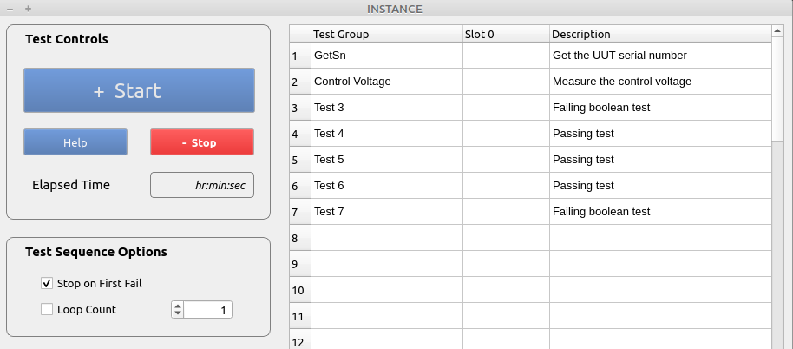
Options
  - The test sequence is executed by selecting the ‘Start’ button.
  - The ‘Stop’ button will synchronously terminate a test sequence
  - When the ‘Stop on First Fail’ checkbox is selected, execution will stop after the first failure.
  - When ‘Loop Count’ is selected, the test sequence will be executed ‘n’ times consecutively.

Test Session Execution using the Management Console
Test sessions, sequences and functions can be interactively executed using the Management Console command line input.
This method provides far more flexibility than the graphical test executive interface and is intended to be used during develop, validation and system debug.
When a test sequence is executed from the console, the GUI test executive will be updated with in-process test results and all data is saved.
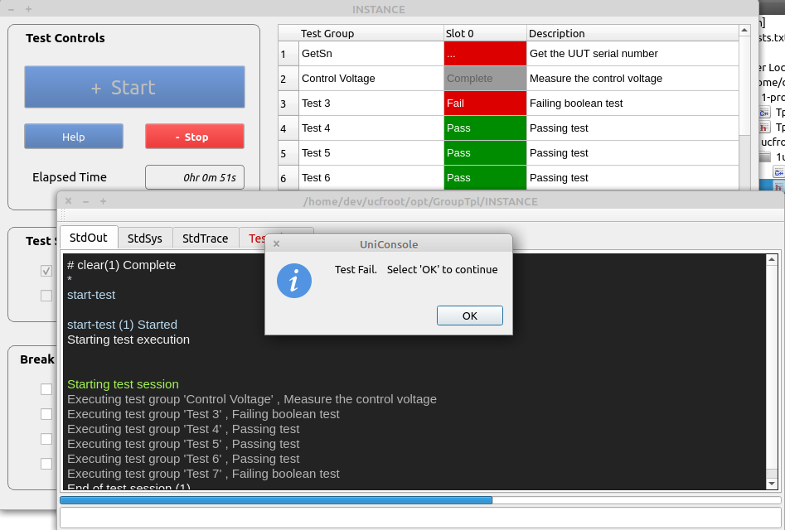
Test Session Options
  - ‘start-test’ will execute a single sequence that does not stop on first fail
  - ‘start-test,1’ will execute a single sequence that stops on first fail
  - ‘start-test*100’ will execute 100 consecutive sequences
  - ‘abort-session’ will asynchronously abort a test session at the end of the current test step
  - ‘stop-session’ will synchronously abort a test session at the end of the current test sequence

Test Function Execution using the Management Console
Interactively executing test functions from the command line is an important tool for test development and station maintenance.
This capability eliminates the need to modify code (comment out sequence functions, and rebuild the module, etc) in order to execute a single test.
  - Data is displayed in the ‘StdOut’ tab
  - The GUI test executive is not updated
  - The test data is not saved to the database

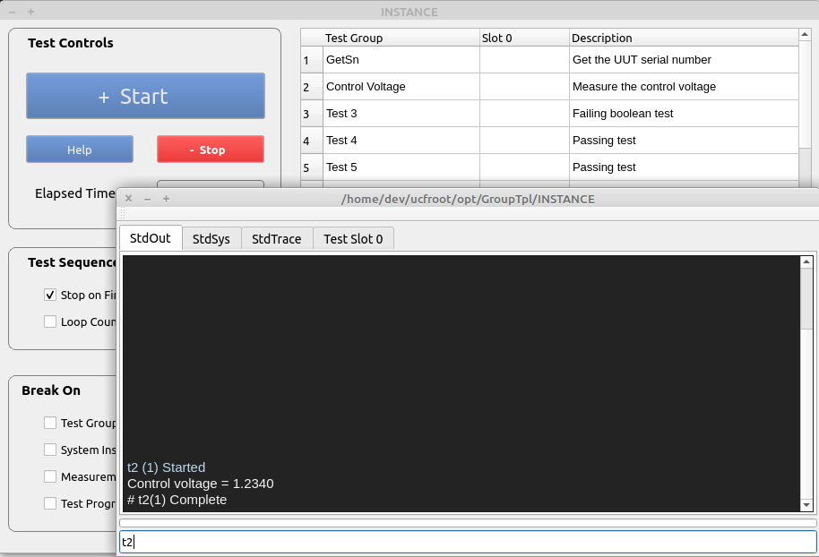
Command Options
  - ‘t2’ will execute the registered test function (‘Test Control Voltage’ from the test executive)
  - ‘t2 *100’ will execute the registered test function 100 times

Viewing Utility Commands
Entering ‘help’ and the command line input will show a list of registered utility commands.
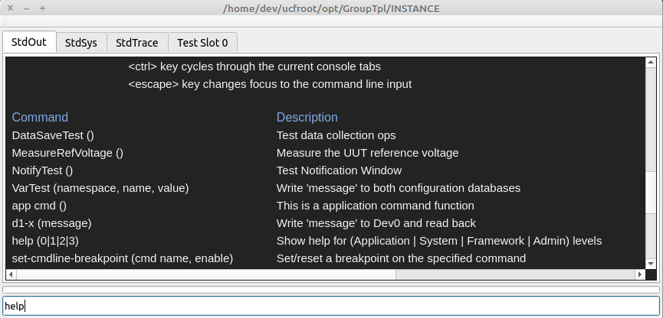

Executing Utility Commands.
A registered utility command can be executed by entering the name in the command line input.
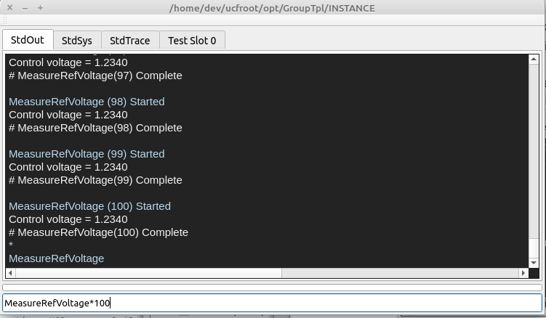
  - ‘MeasureRefVoltage <cr>’ will execute a single instance of the command
  - ‘MeasureRefVoltage * 100 <cr>’ will execute the command sequentially 100 times
  - The command line input uses ‘tabbed command completion’ as necessary

The Development Process Outline
This section outlines the process of creating a plugin module using the UCF software package.
  - A Test profile is created
  - A C++ Software Development Project is Created
  - IO Channels are Defined and Initialized
  - UCF API Functions are Developed
  - UCF API Functions are Registered as Commands or Test Steps
  - UUT Test Sequences are Verified

Test Profile Creation
This section outlines creating a test profile and test profile group.
A ‘test profile group’ is a directory containing common resources and 1 or more subdirectories that contain test applications. Common resources include:
  - Utility module requirements (utility UCF plugins)
  - Instrumentation addressing requirements
  - System Variables
  - Path-Link definitions

Creating a Test Group & Profile Structure
A test group directory structure is created using a copy of the sample structure (./ucfroot/opt/GroupTpl/ ) in the UCF distribution.

  - The new Test Group’ is named ‘PcbFunctional’ and the TestProfile ‘INSTANCE’ is renamed to ‘TestSuite_1’

~/ucfroot/ (or c:\ucfroot\)
:
├── opt/
│ └── GroupTpl/
: │ ├── Etc/
: │ ├── ExtendedCommands/
: │ ├── CommonLibs
│ ├── ExtSystemIO.sdb
│ ├── PathLinksEx.sdb
│ └── INSTANCE/
│ ├── LastTest.log
│ :
│
└── PcbFunctional/
├── Etc/
├── ExtendedCommands/
├── CommonLibs
├── ExtSystemIO.sdb
├── PathLinksEx.sdb
└── TestSuite_1/
├── LastTest.log
:

Directory and File Descriptions
Directory or Filename | Description
./Opt/ | The directory containing 1 or more test groups
./PcbFunctional/ | A test profile group that contains 1 or more test profiles with their common resources
./Etc/ | Misc configuration files used by all local profiles
./ExtendedCommands/ | External programs and utilities used by all local profiles
./CommonLibs/ | Shared libraries that are automatically loaded when executing and local profiles.
ExtSystemIO.sdb | Sqlite database containing system variable and instrument addresses used by all local profiles
PathLinksEx.sdb | Sqlite database containing directory and filename aliases used by all local profiles
./TestSuite_1/’ | A unique test profile.  This sub-directory is the target for Qt & Visual Studio C++ projects.

Software Development Project Creation
This section provides an overview of how to create a test application project using Qt or Visual Studio. The project and support files are found in the distribution directory.

./ucfrooot
└── usr
└── src
├── TplModule
│ ├── CMakeLists.txt
│ └── src
│ ├── TplModule.cpp
│ └── TplModule.hpp
│
├── UCF-<Distribution Name>
: └── Api
: ├── ...
: :

Project Creation
The project is created by copying the TplModule directory to the ./ucfroot/usr/src/<your project name> location.

Project Configuration
The project is configured by editing the CmakeLists.txt file.
- Configure the CmakeLists.txt to use the correct directories for all source files.
- Configure the CmakeLists.txt to create the output in the ‘TestSuite_1’ profile directory (see section 7).
- Open the CmakeLists.txt file directly with Qt, or use cmake to create the Visual Studio project.

Project Verification
- Verify the project by ‘Rebuilding All’.
- Execute the project output using the following command line syntax:
‘./ucfroot/bin/UniConsole(.exe) -c ./ucfroot/opt/PcbFunctional/TestSuite_1’

UCF API Functions
UCF API functions are methods that have been registered as either utility commands or test executive steps.
Utility commands can be used to interactively control a test station independantly of any test sequences.
Test executive steps are executed as part of a test sequence, or interactively by the Management Console.

Registering a Utility Function
A utility function is registered in the TplModule.h/cpp files.

Example Code
int TplModule::Start() {
/* Register the function to be called from the command line */
if (Cmds) {
Cmds→RegisterApplicationCmd(
"MeasureRefVoltage",
new Ucfx(&TplModule::TestInstrumentControl,this),
"(range), resolution)\tMeasure a voltage"
);
}
return(1);
}
Where:
  - “MeasureRefVoltage” is the name of the command
  - TplModule::TestInstrumentControl is the name of the function to be registered
  - "(range), resolution)\tMeasure a voltage" is the description displayed by the help command

Registering aTest Step
A test step is registered in the TplModule.h/cpp files.
Test steps will appear in the test executive (and execute) in the order of registration.

Example Code
int TplModule::Start() {
/* Register UCF API functions */
if (TheTestExec) {
TheTestExec→RegisterTestMgr(
new Aobj<TplModule,TestXtor>(&TplModule::ManageTestSequences,this)
);
TheTestExec→RegisterTestFunction(
"GetSn",
"()\tGet the UUT serial number",
new Ucfx(&TplModule::Test1, this)
);
TheTestExec→RegisterTestFunction(
"Control Voltage",
"()\tMeasure the control voltage",
new Ucfx(&TplModule::MeasureControlVoltage, this)
);
. . .
. . .
}
return(1);
}
Where
  - The first registered test step is to verify the serial number that was input, or read from the UUT
  - "Control Voltage" is the name of a test step to be registered that will call TplModule::MeasureControlVoltage

Creating a UCF API Function
UCF API functions are used to create either utility or test functions. API functions
  - May be executed by the test executive
  - May be executed from the command line input.

Example Code
int TplModule::MeasureControlVoltage(CmdParam msg) {
/* Measure a voltage and display the value in the StdOut tabbed window */
double measurement_value {1.234};
/* The variable is for demo purposes only */
iUcfTestExec exec(msg,ModuleId);

measurement_value = iSystem->MeasureControlVoltage();
/* Demo code that will execute when invoked by the console
and test executive
*/

if (exec.IsValid()) {
/* Code that will execute when invoked by
1. The test executive
2. The ‘start-test’ command
*/
exec.SaveMeasurement("Test A","IsValid",measurement_value,1.0,3.0);
/* Save a measurement to the database and set the
initial pass/fail limits in the test limit database on the first call
1. 1.0 is the low test limit (value >= 1.0)
2. 3.0 is the high test limit (value<=3.0)
*/
exec.SaveMeasurement("Test B","IsValid",measurement_value,1.0,3.0,false);
/* Save a measurement to the database and use the passed test limits
only.
The test limit database values are ignored
1. 1.0 is the low test limit (value >= 1.0)
2. 3.0 is the high test limit (value<=3.0)
*/
exec.SaveMeasurement("Test A","IsValid",measurement_value,15);
/* Save a measurement to the database and set the pass/fail limits in
the test limit database as a percentage of the measurement value
on the first call.
1. measurement_value-15% is the low test limit (value >= 1.0)
2. measurement_value+15% is the high test limit (value<=3.0)
*/
exec.WriteTestOuput(“A message”, <Option>);
/* Display messages to the current test slot tabbed console output */
}
else {
/* Code that will only execute when invoked by the console */
StdOutConsole.Write(
IOString("Control voltage = %2.4f",measurement_value), <Option>
);
/* Write a message to the StdOut tabbed console output */
}
return(1);
/* ‘1’ is always returned */
}
Where <Option> is defined as one of the following values:
iStdOut::Pass // green text
iStdOut::Warning // yellow
iStdOut::Error // red text
iStdOut::SystemSoftError // yellow text
iStdOut::SystemHardError // dark red text
iStdOut::Text1 // normal text
iStdOut::Text2 // normal text-1 point size
iStdOut::Text3 // normal text-2 point size
iStdOut::GrayText // gray text
iStdOut::ItalicText // white italic text
iStdOut::Directory // blue text
iStdOut::Filename2 // light blue text
iStdOut::Filename3 // yellow text
iStdOut::Filename3 // white text

Additional iUcfTestExec methods
The iUcfTestExec object contains the following methods:
  - iUcfTestExec* GetMfgId(
unsigned &id, imx::IOString &name,
imx::IOString &location
);
/* Get the manufacturer ID from the configuration database */
  - iUcfTestExec* SetSn(const char *sn);
/* Set the serial number for the current UUT */
  - const char* GetSn();
/* Get the serial number of the current UUT that was input using
the test executive dialog
*/

IO Channels
IO channels are a software structures that define the target and any relevant communication parameters.
The UCF uses IO channels to communicate with external instrumentation and target UUT’s.

Defining IO Channels
Definitions for all IO connections are defined in an embedded Sqlite database.

Database Locations
The configuration databases are located in the following directorys
  - ~/ucfroot/bin/<UCF Release Name>/IOConfig/BaseSystemIO.sdb contains address information that is global to all profile groups.
  - ~/ucfroot/opt/PcbFunctional/ExtSystemIO.sdb contains address information that is local to the ‘PcbFunctional’ profile group.

Defining Communication Parameters
The DbBrowser for Sqlite application is used to define instrument address information.

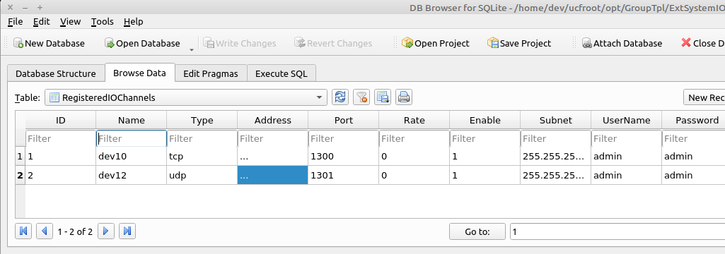
** This image is only representative of the database and may vary for older distributions

Viewing IO Channel Definitions
The contents of both databases can be viewed using the ‘ls-dev’ command.
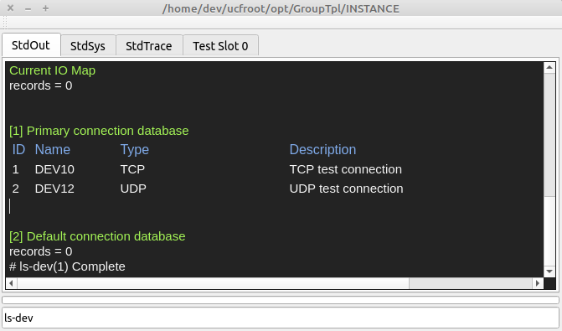

Creating IO Channels
IO channels are created on system startup and de-allocated on program exit.
Creating an IO channel is not the same as ‘opening’ a connection.

Location
Connections are created in TplModule::SetStaticConfiguration(…) { . . .}

Creating Instrument IO Channels
TheSystem→RegisterIOChannelDevice(int device_id, char *description) is used to create and verify an instrument IO connection.
Where:
  - int device_id corresponds to the name (dev0-n) in the adress configuration database
  - char *description is the description that will be displayed when executing the ‘ls-io’ command
  - An iIOConnectionDevice* will be returned on success, and nullptr on failure

Creating UUT IO Channels
TheSystem->GetTmpIOChannelDevice(int device_id) is used to create an IO channel that will be used to communicate with a UUT.
Where:
  - int device_id corresponds to the name (dev0-n) in the adress configuration database

Viewing Instrument IO Channels
Registered IO channels can be viewed using the ‘ls-io’ command.
UUT IO channels will not be displayed.
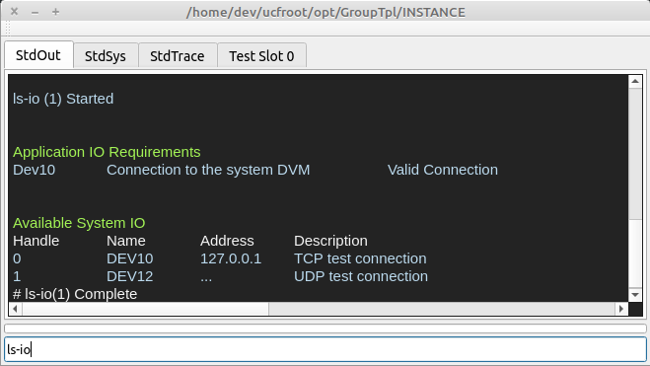

Example Code

iIOChannelDevice *DvmIO { nullptr };
iIOChannelDevice *UutIO { nullptr };

void TplModule::SetStaticConfiguration() {
/* set the static configuration for the system
1. assign system interfaces to individual instruments
*/

DvmIO=TheSystem→RegisterIOChannelDevice(10,"Connection to the system DVM");
/* Create a connection to an external instrument
1. The database entry for ‘dev10’ is used to create the connection
2. “Connection…” is the description that will be displayed when using
the ‘ls-io’ command
3. nullptr is returned on failure
4. For ethernet connections, the target is ‘pinged’ to verify
the connection
*/
UutIO=TheSystem.GetTmpIOChannelDevice(13);
/* Create a connection to the UUT
1. The database entry for ‘dev13’ is used to create the connection
2. nullptr is returned on failure
4. The UUT does not have to be connected when calling this function
*/
}

External Device Control
IO channels are used to write to external instruments and target UUT’s, and read back results when available.
Operations include:
  - Initialization
  - Written to/read from
  - Configuration to an idle state on test sequence end, and program shutdown

Initialization
Instrumentation is initialized and configured at startup to minimize test times and to identify any related system issues as soon as possible.

Code Location
Code is inserted in the TplModule::ThreadedStartup(…) function which executes on startup, in a seperate thread in order to keep the user interface responsive.
  - The progress bar will be active while the ‘ThreadedStartup(…)’ function is executing
  - Real-time status information will be displayed in the Management Console

Exceptions
All exceptions that are thrown in the thread are caught at the end of the function and will lock the test executive to prevent test operations after a failed instrument configuration process.
  - The system locked state can be cleared using the ‘lock,0’ command.
  - The current system lock status can be viewed using the ‘lock’ or ‘status’ command

Example Code
void TplModule::ThreadedStartup(iIXmgr *ix) {
try {
TheAppEngine->iErrorManager()->LockEngine(true);
TheAppEngine→IncrementActiveThreadCount();

if (DvmIO→Open()) {
DvmIO->Write (“CONF:VOLT:DC 10,.001);
/* Set the full scale range and resolution */
...
}

TheAppEngine->iErrorManager()->LockEngine(false);
}
catch(IOString msg) {
TheAppEngine->iErrorManager()->SetHardError(msg);
}
catch(...) {
TheAppEngine
→iErrorManager()
→SetHardError("Unknown exception while initializing the system");
}
TheAppEngine->DecrementActiveThreadCount();
}

Instrument & UUT Control
Instruments can be controlled by UCF API functions using registered & tmp connections.

Example Code
int TplModule::ReadDvm(CmdParam msg) {
/* Configure and control an Agilent 34461 DMM */
std::string response;
float measurement_value {0};
try {
iIOChannelDevice::Guard dvm_guard(DvmIO);
iIOChannelDevice::Guard uut_guard(UutIO);
/* Open instrument & UUT connections
1. An exception will be thrown if the connection has not been defined
or cannot be opened
*/
dvm_guard->Write (“READ?”);
TokenString instrument_result(dvm_guard->GetReadBuffer(),',')
/* Read the input voltage */
instrument_result.GetToken(1,measurement_value);
/* Parse the result */
StdOutConsole.Write(
IOString("Control voltage = %2.4f",measurement_value),
iStdOut::Text1
);
/* Display the result to the StdOut console */

uut_guard->Write (“<command>”);
TokenString result(uut_guard->GetReadBuffer(),',')
/* Write a command to the UUT and read the result */

result.GetToken(1,response);
/* Parse the response */
StdOutConsole.Write(
IOString("Command response = %2.4f",response.c_str()),
iStdOut::Text1
);
/* Display the response to the StdOut console */
}
catch(iIOChannelDevice::Guard connection) {
/* If dev13 does not exist in the configuration database */
StdOutConsole.Write(connection→GetErrorMsg()), iStdOut::Error);
}
catch(iIOChannelDevice::Guard connection) {
/* If the connection could not be opened */
StdOutConsole.Write(connection→GetErrorMsg()), iStdOut::Error);
}
catch(iIOChannelDevice::Guard connection) {
/* Any other exception*/
StdOutConsole.Write(“An . . . error occurred”), iStdOut::Error);
}
return(1);
}

UUT Configuration on Test Sequence End
In many cases, a UUT must be set to an idle state on shutdown

Example Code
int TplModule::ManageTestSequences(TestXtor xtor) {
/* manage sequence and session construction/destruction
throw(IOString msg) to terminate the sequence
*/
int ret {1};
switch(xtor.GetXtorType()) {
case(TestXtorType::SequenceCtor):
/* Execute at the start of a test sequence */
break;
case(TestXtorType::SessionCtor):
/* Execute at the start of a test session */
break;
case(TestXtorType::SessionDtor):
/* Execute at the end of a test session */
/******************************
Insert custom code here
******************************/
break;
case(TestXtorType::SequenceDtor):
/* Execute at the end of a test sequence */
break;
}
return(ret);
}

Instrument Configuration on Shutdown
Instrumentation should be set to an ‘idle’ state on program termination.
The TplModule::Shutdown() function is automatically called on program termination.

Example Code
void TplModule::Shutdown() {
/* Shutdown the lib on program termination
1. Set any instrumentation to an idle/safe state
2. De-allocate as necessary
*/
iSystem→DisableSystemPowerSupplyOutput(…);
/* This is a demo function to disable the system power supply’s output */
}

